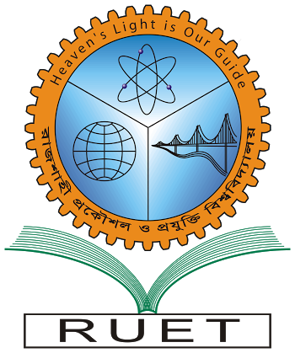“Heaven’s light is our guide”

**Rajshahi University of Engineering & Technology**

**Department of Computer Science & Engineering**

**Course No: EEE 2252**

**Course Title: Electrical Machines and Instrumentations Sessional**

Experiment No: 01

Experiment Name:Observation of **no-load magnetization** curve of a separately excited DC generator.

|  |  |
| --- | --- |
| Submitted By:  ***Saifur Rahman***  *Roll No:* ***1703018***  *Section: ’17-A*  *Class:2nd year (Even Semester)* | Submitted To:  ***MD. Tarek Hossein***  *Lecturer,*  *Dept. of EEE,*  *RUET.* |

***Date of Experiment: 7th January, 2020***

***Date of Submission: 9th February, 2020***